Step 0 Source: Intake Result: Filing Status, Dependency
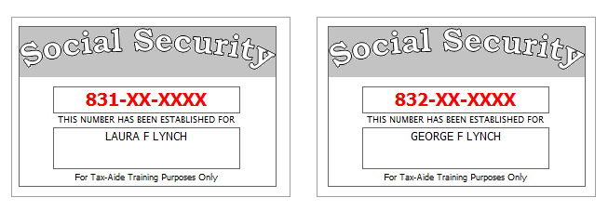
As you are going over Form 13614-C with Laura, you discover that there are a few answers that need to be corrected.
Laura had a serious accident in June, 2014, and stopped working. Laura is now totally and permanently disabled.
Laura’s divorce decree states that her ex-husband is to claim their son, John, as a dependent on his return even though Laura provides all the support for their children. Laura has provided her ex a signed form 8332 to facilitate this.

Reference: 4012 Tab A, B, C
Tool: IRS Interactive Tax Assistant (link on Preparer page)
Tool: AARP Resource Tool for Counselors (Laminated Flow Chart)
Tool: TP4F Qualifying Child/Qualifying Relative Flowchart Tool (link on Preparer page)
Tool: Dependent Calculator (link on Preparer page)

Step 1a Source: Intake Part I, II, VII TWO Screen: Main Info
Reference: 4012 K-6, K-7
Use the Filing Status and Dependency Status from Step 0
Refund Monitor
AGI | Refund | NJ 39 | NJ 56/66 | Notes
 |  |  |  | Hint: Don’t worry about RTN / DAN for direct deposit at this point.
Step 1b Source: Intake Part I TWO Screen: NJ 1040 Pg1
Reference: NJ Special Handling p5
Tool: NJ Municipality Code Lookup Tool (link on Preparer page)
Tool: NJ 1040 Instructions – Municipality Code Table
Tool: TWO State Help
Refund Monitor
AGI | Refund | NJ 39 | NJ 56/66 | Notes
 |  |  |  | Hint: Use NJ Municipality Code Lookup Tool
Step 1c Source: Intake Part I, II TWO Screen: NJ 1040 Pg 2
Laura’s contribution to the Gubernatorial Election Campaign Fund will be handled the same way as her contribution to the Presidential Election Campaign Fund.
Everyone on the return had MEC (Not from the Marketplace) all year.
Reference: NJ Special Handling p5
Refund Monitor
AGI | Refund | NJ 39 | NJ 56/66 | Notes
Hint: Gubernatorial Elections Fund – see Notes
Hint: Wait to make changes to NJ Dep Wkt until we know TP is eligible for EIC
Step 1d Source: Intake Part VII TWO Screen: Prep Use
If asked, Laura is a Veteran from the US Armed Forces.
Refund Monitor
AGI | Refund | NJ 39 | NJ 56/66 | Notes
 |  |  |  | BP: Do not fill in line 14 until after QR

Step 2 Source: Prior Year Return TWO Screen: Various
She had a NJ refund of $502 which matches the NJ Lookup amount.
Looking at last year’s return, you notice:
- Her filing status was the same as this year.
- 1040 Line 39a (65 or blind) had no boxes checked
- 1040 Line 40 (Itemized deductions) was $9,145 including using State Income Tax (5a) of $890 instead of State Sales Tax (5b) of $655.
- 1040 Line 41 (AGI minus itemized deductions) was $7,680.
- 1040 Line 42 (Exemptions) was $7,800.
- 1040 Line 43 (Taxable Income) showed 0.
- She did not have any unused refundable credits
Step 2a Source: Prior Year Return TWO Screen: 1040 Pg 1
Reference: NJ Special Handling p2
Refund Monitor
AGI | Refund | NJ 39 | NJ 56/66 | Notes
0 | 0 | 0 | 0 | Hint: Answer the question above line 10  Hint: Link to St Tax Refund from line 10
Step 2b Source: Prior Year Return TWO Screen: St Tax Refund
Reference: 4012 D-12
Refund Monitor
AGI | Refund | NJ 39 | NJ 56/66 | Notes
75 | 0 | 0 | 0 | BP: Attach Scratch Pad to line 12 to document calculation of prior year taxable income
Step 3 Source: W-2 TWO Screen: W2
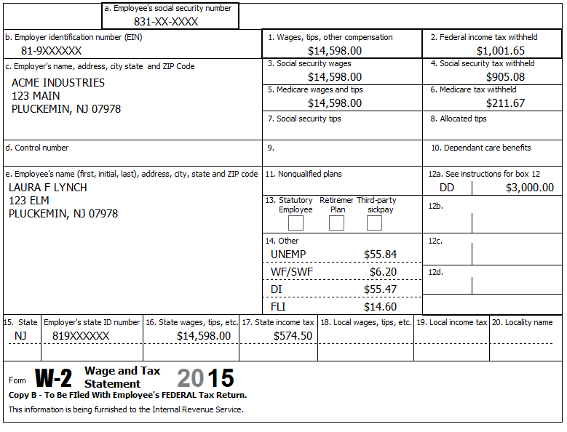
Reference: 4012 D-6
Reference: NJ Special Handling p1
Refund Monitor
AGI | Refund | NJ 39 | NJ 56/66 | Notes
14,673 | 7,462 | 11,098 | 1,667 | Check: Sch A, Line 5a = 707  Check: NJ 2450 TP, line 2, A=62, B=55, C=15
Step 4a Source: W-2 TWO Screen: W2
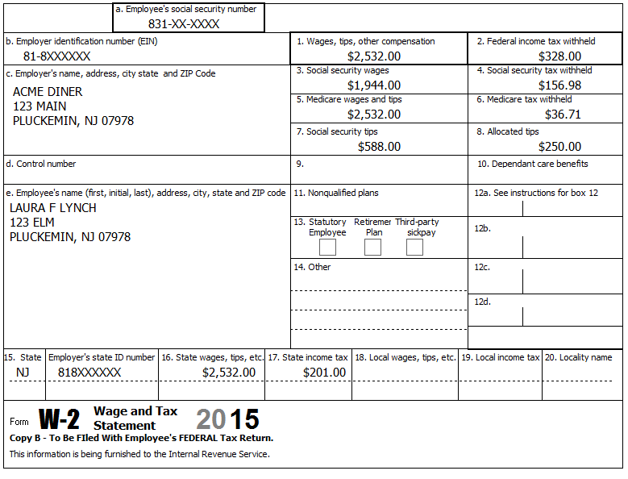
DI PP# 9786654
10.76 UI/WF/SWF
72.06 DI
2.53 FLI
Reference: 4012 D-6
Reference: NJ Special Handling p1
Refund Monitor
AGI | Refund | NJ 39 | NJ 56/66 | Notes
17,455 | 7,724 | 13,880 | 1,868 | Hint: If the checkbox for “Please verify the Federal withholding, …” turns red, double check your entries in Box 1 & 2, then check the box  Hint: Enter box 7 and 8 before taking calculations off 3, 4, 5, 6  BP: Use Type NJSDIPP for Private Plan disability  Check: Sch A, Line 5a = 922
Step 4b Source: W-2 TWO Screen: NJ 2450 TP
Reference: NJ Special Handling p7
Refund Monitor
AGI | Refund | NJ 39 | NJ 56/66 | Notes
17,455 | 7,724 | 13,880 | 1,875 | BP: Use Scratch Pad linked to Line 1b, Col B to document source of DI PP# amount  Check: NJ 2450 TP, line 2, A=73, B=127, C=18  Check: NJ 1040 Pg 3, Line 53 = 7
Step 5a Source: 1099-R TWO Screen: 1099R
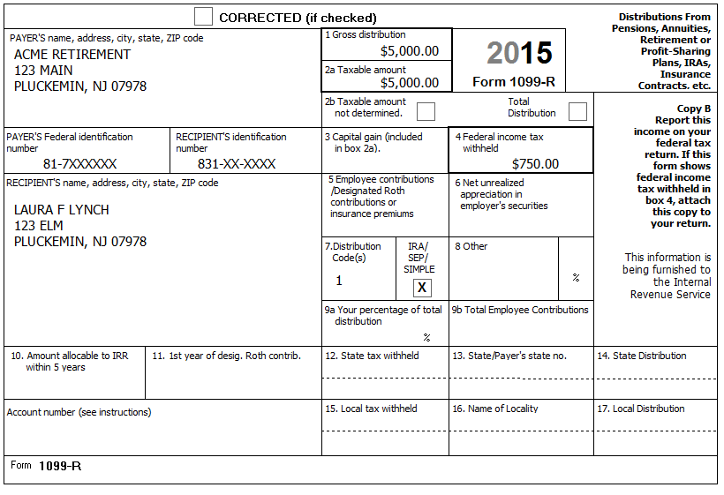
In January, Laura took an IRA distribution of $5,000 to pay off credit card debt.
Reference: 4012 D-20, D-21, H-2
Refund Monitor
AGI | Refund | NJ 39 | NJ 56/66 | Notes
22,455 | 6,494 | 13,880 | 1,679 | Check: NJ 1040 Pg 2, line 19a = 0  Q: NJ 39 doesn’t change – Why does NJ refund go down?
Step 5b Source: Notes TWO Screen: NJ IRA Wkt
Laura has no records of her IRA contributions.
Reference: NJ Special Handling p7
Refund Monitor
AGI | Refund | NJ 39 | NJ 56/66 | Notes
22,455 | 6,494 | 13,880 | 1,679 | Check: NJ 1040, line 19a = 5,000  Check: NJ 1040, line 27c = 5,000
Step 6 Source: 1099-R TWO Screen: 1099R
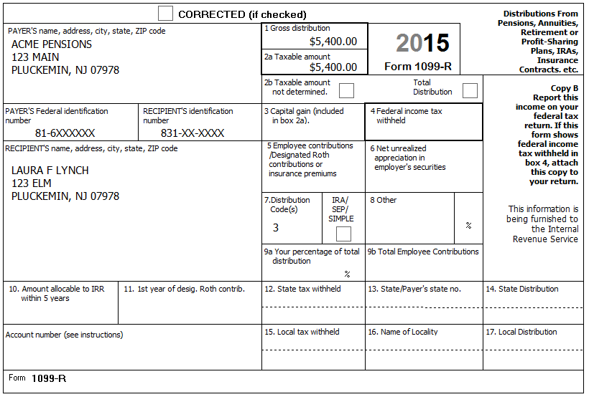
The minimum retirement age for Laura’s job was 59.
Reference: 4012 D-20, D-21
Reference: NJ Special Handling, p3
Refund Monitor
AGI | Refund | NJ 39 | NJ 56/66 | Notes
27,855 | 4,817 | 13,880 | 1,452 | Hint: Code 3 is disability (Where would you look to find this out?  Hint: Use context sensitive help on “Check if disability…” box  Check: 1040 Line 7 = 22,780  Check: NJ 1040 Pg 2, Line 14 = 17,380

Step 7a Source: Notes TWO Screen: Sch C Pg 1
Starting on July 1, 2011, Laura started providing freelance editing services from her home. She had no separate business name, no EIN, and no business address (other than her home). She met all requirements for Schedule C-EZ. She did not make any payments that would require her to file Form(s) 1099.
Reference: 4012 D-14
Tool: NAICS Search Tool (link on Preparer page)
Tool: 1040 Instructions, Sch C Business Codes table
Step 7b Source: Notes TWO Screen: 1099 MISC
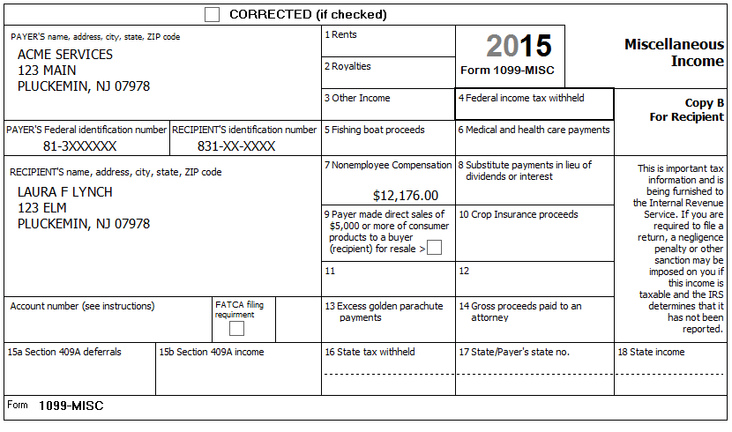
Reference: 4012 D-14
Refund Monitor
AGI | Refund | NJ 39 | NJ 56/66 | Notes
39,171 | (874) | 26,056 | 590 | Hint: Attach 1099-MISC to line 1 of Sch C  Check: Sch C Pg 1, Line 1 = 12,176

Step 7c Source: 1099-MISC TWO Screen: Sch C Pg 2
She kept a record of her expenses: $2,025 for paper, $1,047.50 for printer cartridges, $800 for postage, $350 for a business phone line and long distance calls, and 234 total miles for making deliveries. She had 10,000 other miles on her car. Laura has one car which she bought in 2010 and began using for her work when she started working at home. She has a written record of her business mileage.
Reference: 4012 D-15
Refund Monitor
AGI | Refund | NJ 39 | NJ 56/66 | Notes
35,124 | 1,202 | 21,702 | 837 | Hint: Easiest to itemize non-mileage expenses in Part V  Check: Sch C Pg 1, Line 31 = 7,822
Step 8 Source: Notes TWO Screen: 1040 Pg 1
Laura’s divorce decree states that her ex-husband is to pay her $300 per month alimony. Due to the loss of his job during the year, he only paid for 8 months.
Reference: 4012 E-3
Refund Monitor
AGI | Refund | NJ 39 | NJ 56/66 | Notes
37,524 | 336 | 24,102 | 693 | BP: Document using Scratch Pad
Step 9 Source: Notes TWO Screen: 2441
Laura paid the Acme Day Care (EIN 81-0XXXXXX), located at 123 Main, Pluckemin, NJ 07978, for George’s and John’s care while she was at work. She paid the day-care center $1,793 ($890 for George + $903 for John).
While looking for work, Laura paid her sister, Edna Loy (SSN 834-XX-XXXX), $400 to take care of John & George ($200 each). Edna lives next door at 121 Elm. Edna is self-supporting.
Reference: 4012 E-3
Refund Monitor
AGI | Refund | NJ 39 | NJ 56/66 | Notes
37,524 | 840 | 24,102 | 693 | Hint: SSN or EIN entered without dash  BP: Document costs for each child with 2 separate Scratch Pads  Check: Total of line 1 amounts = 2,193  Check: Total of line 2 amounts = 2,193
Step 10 Source: Notes TWO Screen: Sch EIC Wkt
EIC has never been reduced or disallowed.
Reference: 4012 I-7
Refund Monitor
AGI | Refund | NJ 39 | NJ 56/66 | Notes
37,524 | 840 | 24,102 | 693 | Hint: Answer questions in order and only if red
Step 11 Source: Notes TWO Screen: 1040 ACA Wkt
Everyone on the return had MEC (Not from the Marketplace) all year.
Reference: 4012 ACA Tab
Reference: ACA TaxWise Procedures (TY2014 version)
Refund Monitor
AGI | Refund | NJ 39 | NJ 56/66 | Notes
37,524 | 840 | 24,102 | 693 | Hint: Everyone marked as Full
Step 12 Source: Notes TWO Screen: Diagnostics
Run Diagnostics – Resolve any issues.
Step 13 Source: Notes TWO Screen: Various
She took a word processing course in the evening at the library to improve her skills. The tuition was $575. Determine the most advantageous benefit for which she is qualified.
Reference: 4012 Tab J
Step 13a Source: Notes TWO Screen: 1040 Wkt2
Evaluate education expenditure as AGI deduction.
Refund Monitor
AGI | Refund | NJ 39 | NJ 56/66 | Notes
36,949 | 1,079 | 24,102 | 719 | Hint: Make note of total refund: 1,798
Step 13b Source: Notes TWO Screen: 8863 Pg 2
Evaluate education expenditure as Lifetime Learning credit.
Refund Monitor
AGI | Refund | NJ 39 | NJ 56/66 | Notes
37,524 | 955 | 24,102 | 693 | Hint: Make note of total refund: 1,648
Step 13c Source: Notes TWO Screen: Sch C Pg 2
Evaluate education expenditure as Sch C expense.
Refund Monitor
AGI | Refund | NJ 39 | NJ 56/66 | Notes
36,990 | 1,141 | 23,527 | 727 | Hint: Make note of total refund: 1,868 => BEST

Step 14 Source: Notes TWO Screen: NJ Dep Wkt
Because John is not a dependent, but is used for the EIC calculations, he must be manually added to the NJ return (via the NJ Dep Wkt).
Refund Monitor
AGI | Refund | NJ 39 | NJ 56/66 | Notes
36,990 | 1,141 | 23,527 | 727 | Hint: Must use the override function to add John to the list  Check: John shows up on NJ 1040 Pg 2, Line 13b
Step 15 Source: Notes TWO Screen: NJ 1040 Pg 3, Line 45
Laura did not make any out of state purchases for which she would owe Use Tax.
Refund Monitor
AGI | Refund | NJ 39 | NJ 56/66 | Notes
36,990 | 1,141 | 23,527 | 727
Step 16 Source: Notes TWO Screen: NJ 1040 Pg 3, Worksheet F
Laura rented an apartment in Pluckemin (Somerset County). She paid $1,000 per month in rent for 12 months.
Refund Monitor
AGI | Refund | NJ 39 | NJ 56/66 | Notes
36,990 | 1,141 | 23,527 | 777
Step 17 Source: Notes TWO Screen: Diagnostics
Run Diagnostics – Resolve any issues.
Step 18 Source: Notes TWO Screen: NJ DD Wkt
Laura would like any NJ refund or amount due handled the same way as on her federal return.
Refund Monitor
AGI | Refund | NJ 39 | NJ 56/66 | Notes
36,990 | 1,141 | 23,527 | 777 | Hint: Select appropriate option
Step 19 Source: Notes TWO Screen: Diagnostics
Run Diagnostics (and Create e-File) – Resolve any issues
For a client return, the next step would be Quality Review…

